Hormones-regualatory substance that is secreted to stimulate specific cells or tissues.

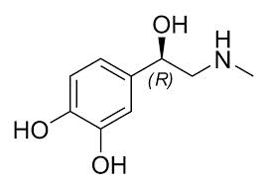

Ex: epinephrine “adrenaline” is secreted by the adrenal gland to increase the heart rate or blood pressure preparing the body to fight or flee.

Gland/ Endocrine gland- glands of the endocrine system that secretes hormones directly into the blood.

Ex: Adrenal gland

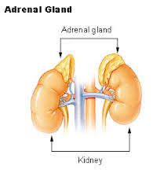

Endocrine system- collection of glands of an organism that secrete hormones

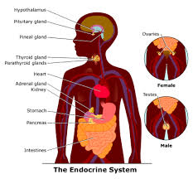

Receptors- after the hormone has reached the target cell, the receptors receive the message of releasing that hormone.

Ex: the epinephrine hormone is released in order to determine fight or flight.

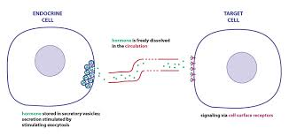

Target cell- after the hormones are sent through the blood they have to reach a target cell in order to activate.

Ex: epinephrine target cell

